Ideation Phase
Define the Problem Statements
Date | 24 September 2026
Team ID | SWTID-2026-7356
Project Name | AI StudyBuddy
Maximum Marks | 2 Marks

Customer Problem Statement:
Students preparing for exams collect large amounts of study material in files such as .txt, .md and .pdf, and they have very little time to go through it. They spend hours writing summaries, making flashcards, creating practice questions and planning their study days by hand, and they have no single, private place where all of this is kept. AI StudyBuddy solves these problems with a secure API where students upload their material and Google Gemini 2.5 Flash generates summaries, flashcards, quizzes and personalised study plans, which are saved for each user and protected by JWT login and student / admin roles.

Problem Statement 1:
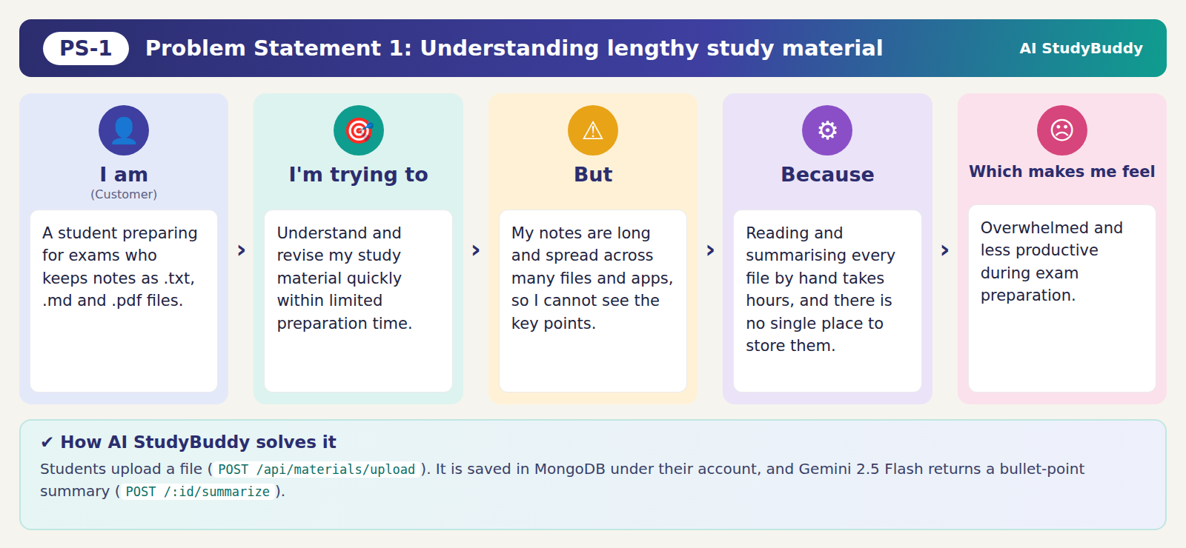

Problem Statement 2:
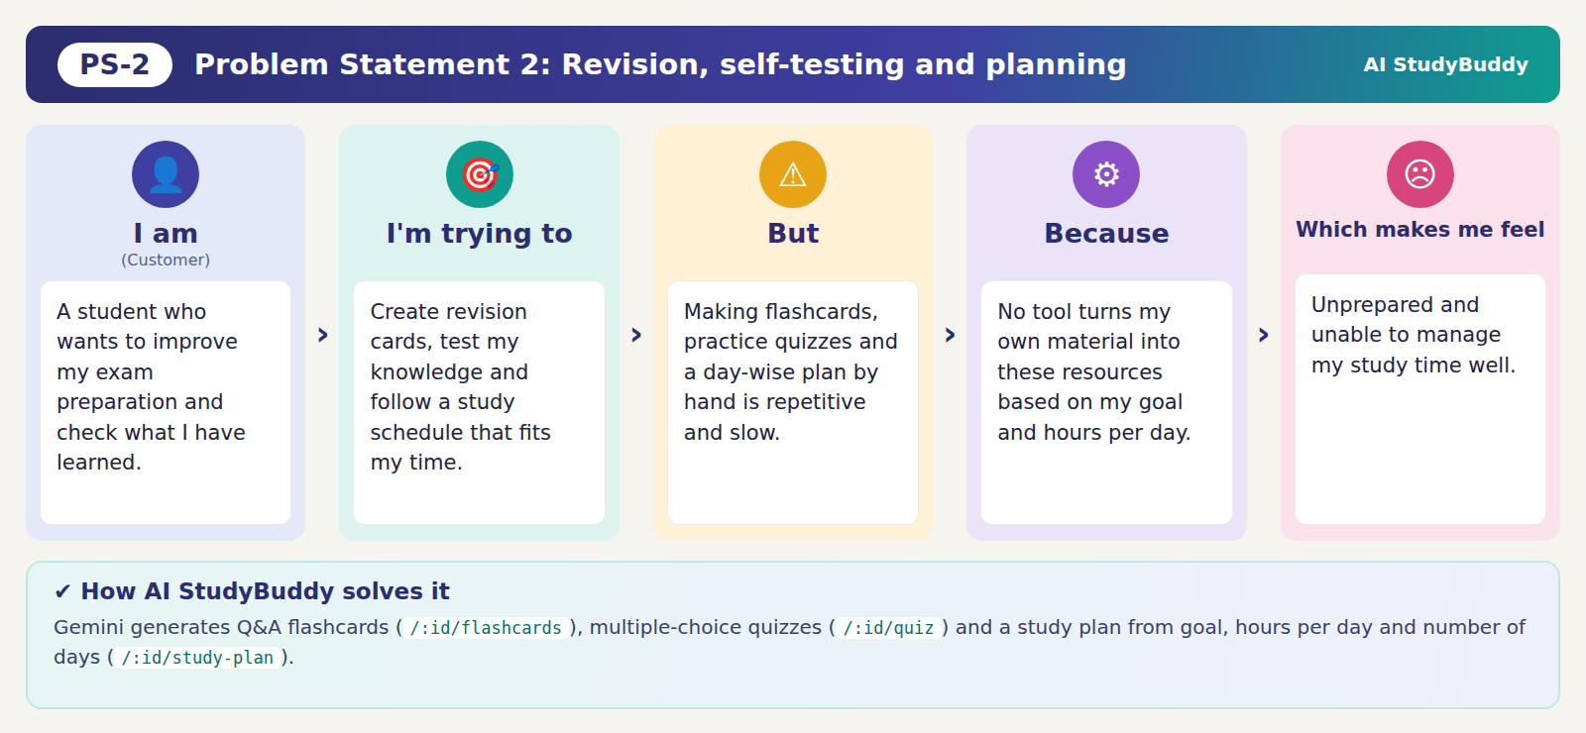

Problem Statement 3:


